**SQL HANDSON 2**

**NAME – ASHI JAIN**

**BATCH – IBM .NET**

--assignment

/* take minprice and max price as input and fetch the data between min

and maximum price and display*/

create procedure GetAllproducts

as

begin

select * from production.products

End

exec GetAllproducts

**OUTPUT ->**

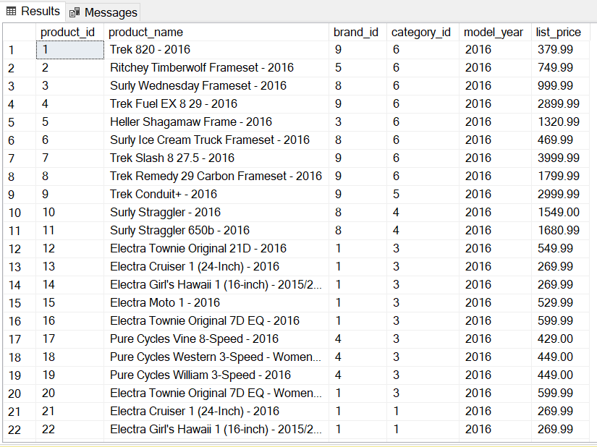

select MIN(list_price)

from production.products

**OUTPUT ->**

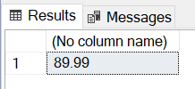

select MAX(list_price)

from production.products

**OUTPUT ->**

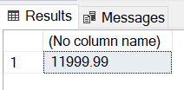

create proc GetMinMaxPriceOfProduct(@minprice as decimal(10,2), @maxprice as decimal(10,2))

as

begin

select product_name,list_price from production.products

where list_price >= @minprice and list_price <= @maxprice

order by list_price

end

exec GetMinMaxPriceOfProduct @minprice = 89.99, @maxprice = 1199.99

**OUTPUT ->**

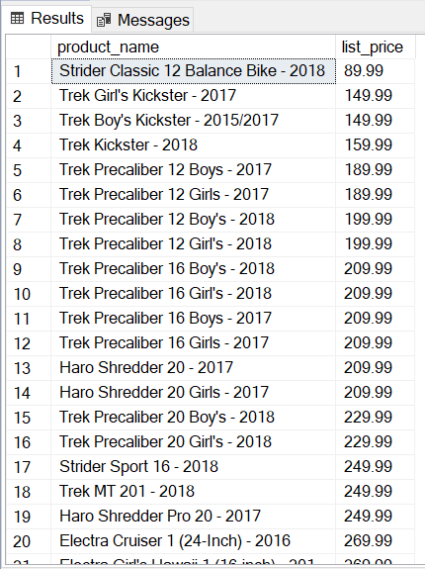

--

alter proc AddNewProduct (@pname varchar(40),@brandid int,

@categoryid int

,@listprice decimal(10,2),@model_year smallint=2020 )

as

begin

insert into production.products (product_name,brand_id,category_id,model_year,list_price)

values(@pname,@brandid,@categoryid,@model_year,@listprice)

End

exec AddNewProduct 'Lenova123',1,1,2019,89000.56

exec AddNewProduct @listprice=9000,@pname='ipad',@brandid=2,@categoryid=3,@model_year=2020

exec Addnewproduct 'laptop',1,1,89000

select * from production.products order by product_id desc

**OUTPUT ->**

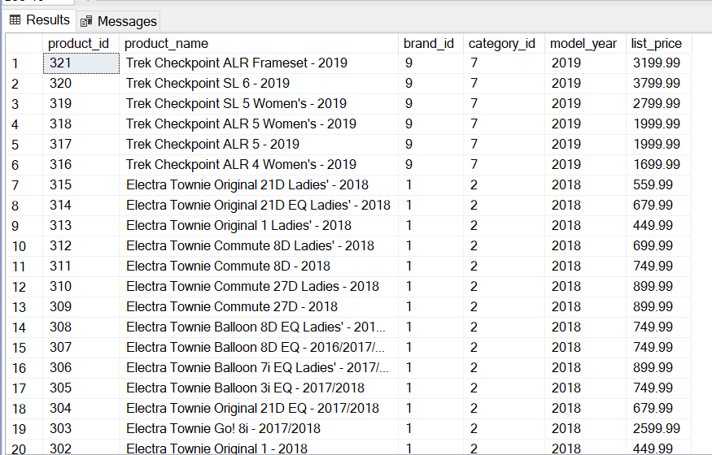

--assignment

/* create procedure for update the record and delete the records */

select * from production.brands

create procedure UpdateRecord (@brandid int)

as

begin

update production.brands set brand_name='Bicycles'

where brand_id = @brandid

end

exec UpdateRecord 7

create procedure DeleteRecord (@brandid int)

as

begin

delete from production.brands where brand_id=@brandid

end

exec DeleteRecord 7

select * from production.brands

**OUTPUT ->**

